**PPiC 5.6** Write a program that reads in a file and then prints out the number of lines, words, and characters in the file.

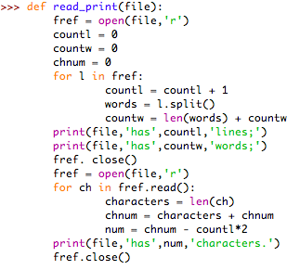

**PPiC 5.7** Write a program that creates a file with a concordance--an index that tells you which line of the file each word appears on. If a word is on more than one line, the concordance will show you all of the lines containing that word. *Hint:* Use a dictionary keyed by each word to solve this problem.

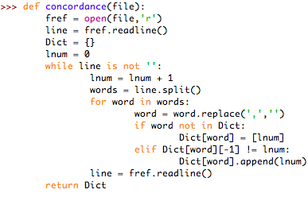

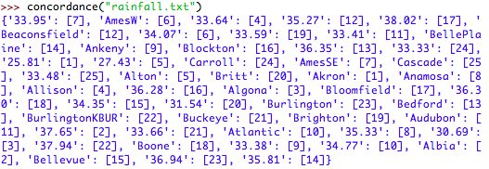

**PPiC 5.13** Write a function called savePage that takes a string representing a URL, and a file name as a parameter and then saves the contents of the web page to the file.

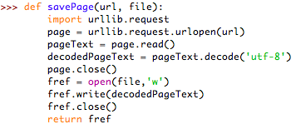

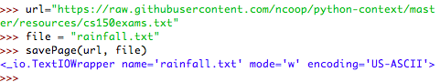

**PPiC 5.18** Use a *while* loop to implement the *for* loop for i in range(10).

